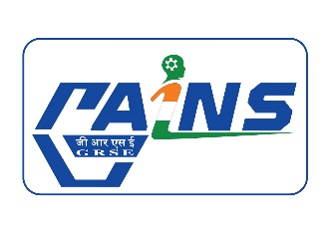

STAGE – I PROPOSAL
Organization name
Problem Statement/ Challenge title
Thematic Area
Challenge Brief/ Definition
- Key features / functions/ capabilities/ required in proposed product / solution
- Expected advantages / Tangible benefits
- Existing solutions (if any)
Future Expectation from the Product/ Technology Developed
Anticipated cost of the Product
Development Time
Advantage expected to accrue to GRSE
Youtube Link/Video Link (3 Minute video explaining the Problem Statement)

